CRM QUERY

# ERD

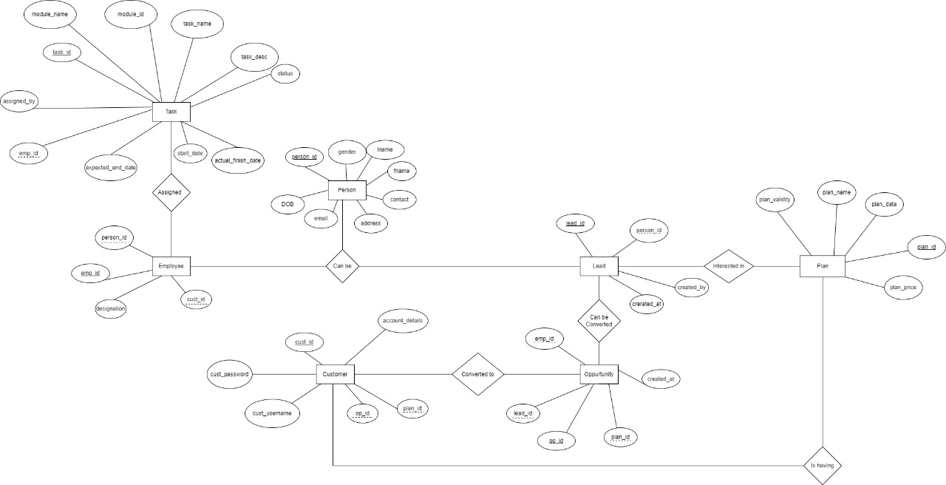

# Create Normalized Tables Create database CRM and create tables create Indexing Use PK, FK, UK

-- creating table task

create table task(

task_id int primary key,

task_name varchar(25) not null,

task_desc varchar(25) not null,

task_status varchar(25) not null,

start_date date,

expected_end_date date,

actual_end_date date,

assigned_by varchar(25) not null,

module_id int,

module_name varchar(25) not null,

emp_id int references employee(emp_id)

);

--creating table person

create table person(

person_id int primary key,

first_name varchar(25) not null,

last_name varchar(25) not null,

gender char(2),

date_of_birth date,

email varchar(255) not null,

contact_no bigint,

address varchar(30)

);

--creating table plan

create table plan(

plan_id int primary key,

plan_name varchar(25),

plan_validity varchar(25),

plan_data varchar(20) not null,

plan_price char(15) not null

);

--creating table employee

create table employee(

emp_id int primary key,

designation varchar(25) not null,

person_id int references person(person_id),

cust_id int references customer(cust_id)

);

--creating table lead

create table lead(

lead_id int primary key,

created_at date not null,

created_by varchar(30) not null,

person_id int references person(person_id)

);

--creating table opportunity

create table opportunity(

op_id int primary key,

created_at date not null,

op_status varchar(30) not null,

emp_id int references employee(emp_id),

lead_id int references lead(lead_id),

plan_id int references plan(plan_id)

);

--creating table customer

create table customer(

cust_id int primary key,

cust_username varchar(30)not null,

cust_password varchar(30)not null,

account_details varchar(30) not null,

op_id int references opportunity(op_id),

plan_id int references plan(plan_id)

);

# Use Limit, Aggregrate Function, Joins, Use Int,decimal,varchar,tinyint,text,date,datetime etc Use views Query to Insert minimum 50 records lead the table.

-- inserting data in person table

insert into person(person_id,first_name,last_name,gender,date_of_birth,email,contact_no,address)

values (01,'Aman','Sharma','M','1998-03-20','aman@gmail.com',489238324,'Pune'),

(02,'Anand','Sharma','M','1999-03-02','anand@gmail.com',390989892,'Pune'),

(03,'Aarohi','Verma','F','2008-11-20','aarohi@gmail.com',909032423,'Patiala'),

(04,'Ravi','Karn','M','2003-08-08','ravi@gmail.com',9902839423,'Delhi'),

(05,'Riya','Raj','F','1995-10-01','riya@gmail.com',988891233,'Mumbai'),

(06,'Sia','Sharma','F','1997-03-03','sia@gmail.com',892323434,'Patna'),

(07,'Sia','Farukh','F','1998-08-05','shreya@gmail.com',999889823,'Delhi'),

(08,'Aditi','Raj','F','1999-03-11','aditi@gmail.com',776879234,'Dehradun'),

(09,'Ajay','Dave','M','1998-05-05','ajay@gmail.com',89983444,'Sikkim'),

(10,'Ajay','Singh','M','1993-04-30','aditya@gmail.com',997732944,'Lucknow'),

(11,'Hiren','haran','M','1996-11-30','hiren@gmail.com',9923483424,'Bangalore'),

(12,'Shilpa','Sharma','F','2001-12-23','shilpa@gmail.com',55399355,'Chennai'),

(13,'Saurabh','Singh','M','1993-12-12','abhishek@gmail.com',88832422,'Pune'),

(14,'Frank','woods','M','1995-11-30','frank@gmail.com',923422444,'Hyderabad'),

(15,'Soap','Mctavish','M','1993-04-30','soap@gmail.com',88324772,'Ranchi')

-- inserting data in lead table

insert into lead(lead_id,created_at,created_by,person_id)

values(1,'2021-09-04',1,1),

(2,'2021-09-09',2,2),

(3,'2020-10-04',2,3),

(4,'2019-10-07',1,4),

(5,'2021-04-04',3,5),

(6,'2021-08-11',3,6),

(7,'2012-12-04',2,7),

(8,'2020-10-05',3,8),

(9,'2021-01-18',4,9),

(10,'2021-03-25',4,10)

-- inserting data in plan table

insert into plan(plan_id,plan_name,plan_validity,plan_data,plan_price)

values(1,'cricket','3 months','20mbps','1500'),

(2,'new year','6 months','30mbps','1800'),

(3,'regular','3 months','15mbps','1000'),

(4,'wfh','8 months','75mbps','2000'),

(5,'christmas','6 months','18mbps','1200')

-- inserting data in opportunity table

insert into opportunity(op_id, created_at, op_status, emp_id, lead_id, plan_id)

values(1, '2021-10-03','true',2,2,1),

(2, '2020-10-10','true',2,3,5),

(3, '2021-10-03','false',1,1,3),

(4, '2021-11-10','true',4,9,4),

(5, '2019-10-10','false',1,4,1),

(6, '2015-10-27','true',2,7,4),

(7, '2021-10-06','false',3,6,4),

(8, '2021-07-03','true',3,5,1),

(9, '2021-08-18','true',4,10,4),

(10, '2021-01-03','true',3,8,5)

-- inserting data in customer table

insert into customer(cust_id,cust_username,cust_password,account_details,plan_id)

values(1,'ravi','ravil123',1,3),

(2,'riya','riya123',2,3),

(3,'anand','anand123',3,5),

(4,'sia','sia123',4,4),

(5,'ajay','ajay123',5,4),

(6,'aarohi','aarohi123',2,4)

-- inserting data in employee table

insert into employee(emp_id,designation,person_id,cust_id)

values(1,'manager',11,1),

(2,'admin',12,4),

(3,'manager',13,5),

(4,'manager',14,4),

(5,'admin',11,2)

-- inserting data in task table

insert into task(task_id, task_name,task_desc,task_status,start_date,expected_end_date,actual_end_date,assigned_by,module_id,module_name,emp_id)

values(1,'t001','lead to customer','on hold','2021-10-19','2022-03-15',null,11,1,'lead',1),

(2,'t002','lead to customer','Done','2021-01-15','2021-02-15','2021-03-03',12,2,'customer',2),

(3,'t003','lead to customer','processing','2021-01-15','2021-12-15',null,13,1,'lead',3),

(4,'t004','new plan to customer','Done','2021-03-13','2021-03-10',null,14,2,'customer',4),

(5,'t005','lead to customer','processing','2021-03-13','2021-10-28','2021-12-01',15,2,'customer',5)

# Query to convert Lead to Opportunity, Account

update opportunity

set op_status = 'true'

where op_id = 3

# Query to get a list of all leads

select * from lead;

# Query to get all leads which converted to Opportunity

select * from lead

join opportunity op

on lead.lead_id = op.lead_id

where op_status = 'true'

# Query to get all leads converted to Account

--Query to get all leads converted to Account

select le.lead_id ,le.created_at, le.person_id, cus.cust_id, op.op_id

from lead le

join opportunity op ON opp.lead_id = le.lead_id

join customer cus ON cus.op_id = op.op_id;

# Query to get All contacts of an Account

select le.lead_id ,le.created_at, le.person_id, cus.cust_id, op.op_id

from lead le

join opportunity op ON op.lead_id = le.lead_id

join customer cus ON cus.op_id = op.op_id;

# Query to get the count of task Module wise

select count(*) from task group by module_id

# Query to get All tasks of Leads, Opportunity, Account

select * from task

where module_name in ('lead','opportunity','customer')

# Query to get all accounts that do not have contacts

select cus.cust_id , pe.person_id, pe.contact_no, pe.first_name

from customer cus

join opportunity op ON op.op_id = cus.op_id

join lead le ON le.lead_id = op.lead_id

join person pe ON pe.person_id= le.person_id

where pe.contact_no = 0;

# Query to get all task which is not created today.

select * from task

where start_date != '2021-12-05'

# Query to get all the task completed

select * from task

where task_status = 'Done'

# Query to get all upcoming tasks

select * from task

where expected_end_date > '2021-12-05'

# Query to fetch account and its contacts with account id, account name

select cus.cust_id , cus.account_details, pe.contact_no, pe.first_name

from customer cus

join opportunity op ON op.op_id = cus.op_id

join lead le ON le.lead_id = op.lead_id

join person pe ON pe.person_id= le.person_id;

# Query to get the count of leads which is converted to account

select count(*)

from lead

join opportunity op

on lead.lead_id = op.lead_id

where op_status = 'true'

# Query to get all Opportunity

select * from opportunity

# Query to get all Opportunity which converted to Account

select * from opportunity

where op_status = 'true'

# Query to get count which plan is taken how many times

select count(plan_id) from customer group by plan_id;